**Information Gathering**

**Using Maltego tool in Kali Linux**

* Maltego is an open-source intelligence forensic application. Which will help you to get more accurate information and in a smarter way. In simple words, it is an information-gathering tool.
* It is pre-installed (in the information gathering section) in Kali Linux.
* Open Terminal and type “maltego” to run Maltego tool:

**Maltego**



* You have to register yourself first to use Maltego and remember your password as you will need it again the next time you login into Maltego. After the registration process, you can log in to Maltego. After that click on Machines and then choose Run Machine.

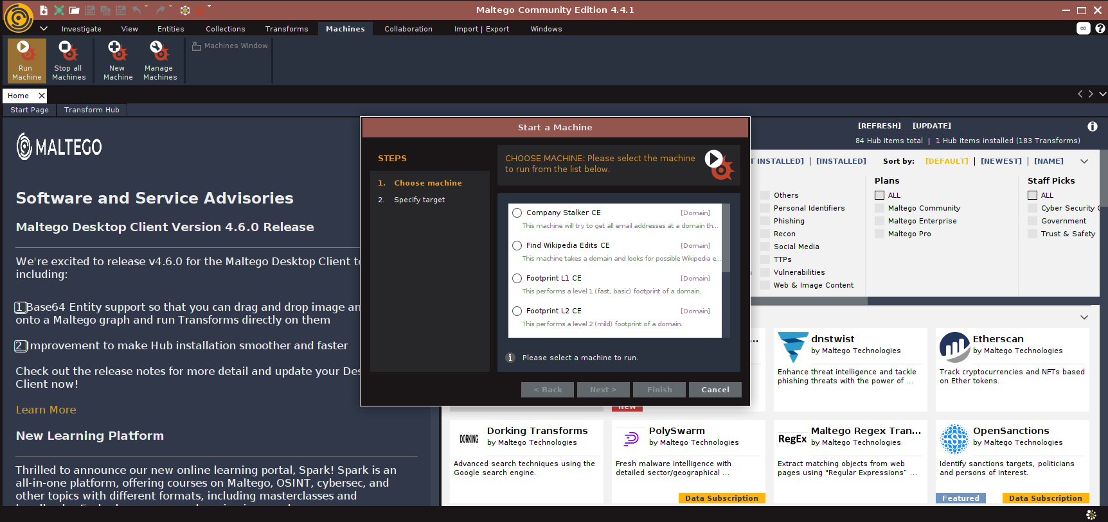

* **Machine**: A machine is simply what type of foot printing we want to do against our target. Select the machine that you want to use.



Select any machine.

* Once we are done with the process of choosing a machine for our footprinting. We need to choose a Target.

* Maltego will now begin to gather info on our target and display it on screen as below:

